**LAPORAN TUGAS**

**MATA KULIAH ALGORITMA DAN STRUKTUR DATA**

Dosen Pengampu : Triana Fatmawati, S.T, M.T

**PERTEMUAN - 13 - 14 Tree**



**Nama : M. Zidna Billah Faza**

**NIM : 2341760030**

**Prodi : D-IV Sistem Informasi Bisnis**

**JURUSAN TEKNOLOGI INFORMASI**

**POLITEKNIK NEGERI MALANG**

**2024**

**Latihan 1**

1. Latihan 1a

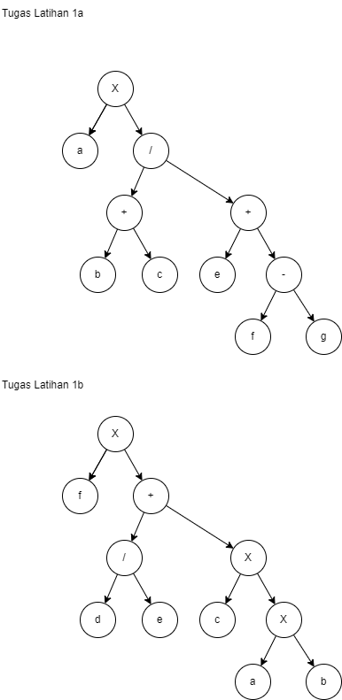

1. Latihan 1b



**Latihan 2**

1. Latihan 2a

Indeks mulai 0

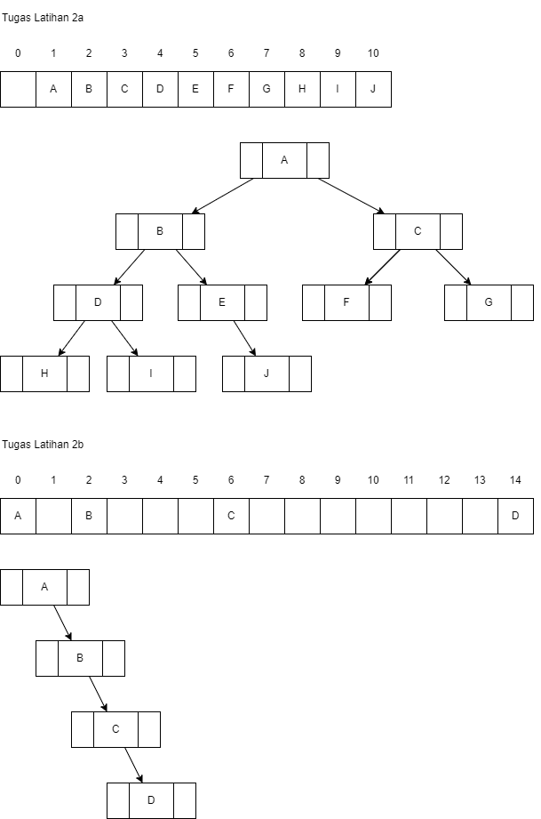

1. Latihan 2b

Indeks mulai 0



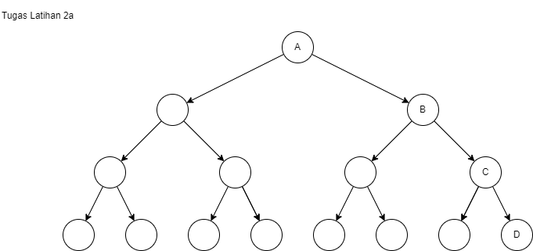



**Latihan 3**

1. Latihan 3a

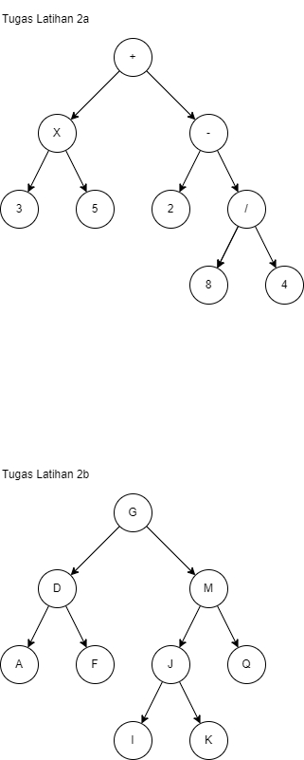

* Preorder Traversal : + * 3 5 - 2 / 8 4
* Inorder Traversal : 3 * 5 + 2 - 8 / 4
* Postorder Traversal : 3 5 * 2 8 4 / - +
* Level Order Traversal : + * - 3 5 2 / 8 4

1. Latihan 3b



* Preorder Traversal : G D A F M J Q I K
* Inorder Traversal : A D F G I J K M Q
* Postorder Traversal : A F D I K J Q M G
* Level Order Traversal : G D M A F J Q I K

**Latihan 4**

1. Find (72)

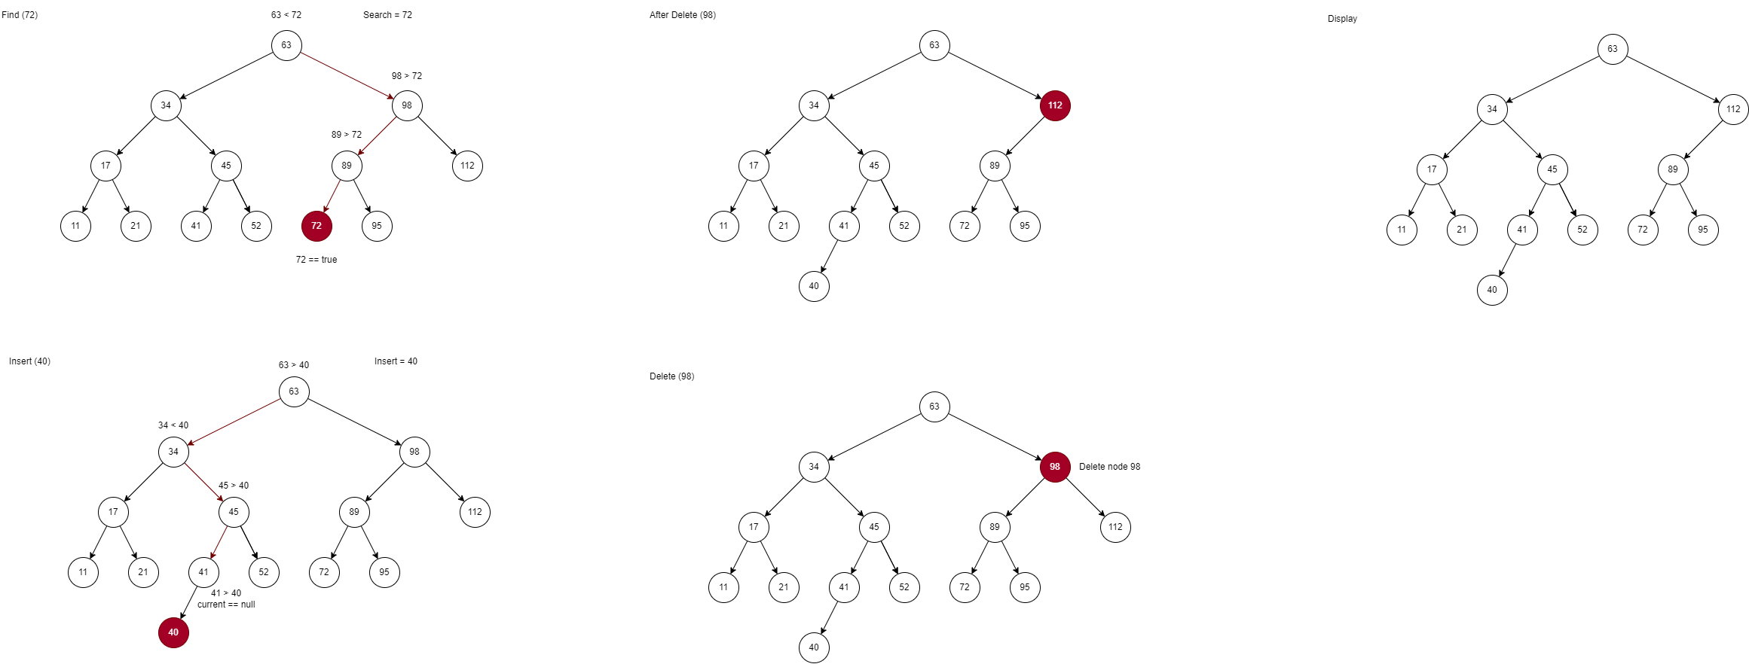

1. Insert (40)



1. Delete (98)



1. Display



Preorder Traversal : 63 | 34 | 17 | 11 | 21 | 45 | 41 | 40 | 52 | 112 | 89 | 72 | 95

Inorder Traversal : 11 | 17 | 21 | 34 | 40 | 41 | 45 | 52 | 63 | 72 | 89 | 95 | 112

Postorder Traversal : 11 | 21 | 17 | 40 | 41 | 52 | 45 | 34 | 72 | 95 | 89 | 112 | 63

Repository GitHub : <https://github.com/zidnafaz/Algoritma-Struktur-Data>